**Assignment #3 (6.7%)**

*(Due Sunday November 15th, 2020 – at midnight*

*Late policy: 10%/day, maximum 1 day.   
Solution will be up on Lea Monday at midnight)*

**Create a Contact Us Page**

**Individually, add a Contact Us Page which sends emails, has a reCaptcha and stores in the database.**

**========**

The objective:

* Create a new ASP.NET Core 3.1 MVC Web application.
* Create a Contact Us form which sends email to the website’s administrator and a copy email to the sender that filled the form.
* The form has front-end and back-end validation using Data Annotations and reCaptcha.
* All form fields are stored in the database with the date and time of creation.

# See the Helper file for the Steps.

|  |  |
| --- | --- |
| Your form needs to have these fields: | |
| **Field Name** | **Data annotation** |
| First Name | Required. Input validation: no numbers. Size 2-50 inclusive. |
| Last Name | Required. Input validation: no numbers. Size 2-50 inclusive. |
| Postal Code | Required. Input validation: accept Canadian postal codes H9X 3L9 |
| Email | Required. Input validation: accept only letters, numbers and periods. Min size: 2 Max size: 30. Check for @ and accept domains such as .com/.ca/.com.br/.cn |
| Topic (drop down list) | Required. See screenshot below. |
| Phone | Not Required. |
| Questions/Comments | Required. |
| Submit button  Reset button | Resets the whole page’s input, including the reCapcha without submitting the page. |
| reCAPTCHA v2 (easier to implement) or v3: | Disable the Submit button until reCAPTCHA is passed.  Have front-end and back-end validation.  Read documentation: <https://www.google.com/recaptcha> |

**Note:** The form should look like this:   
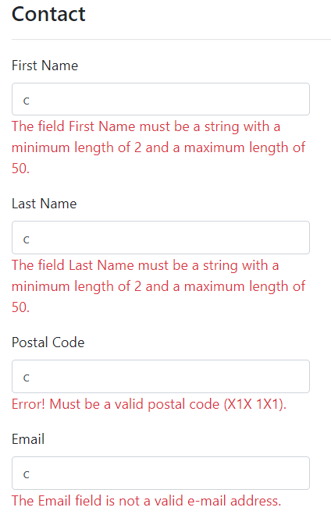

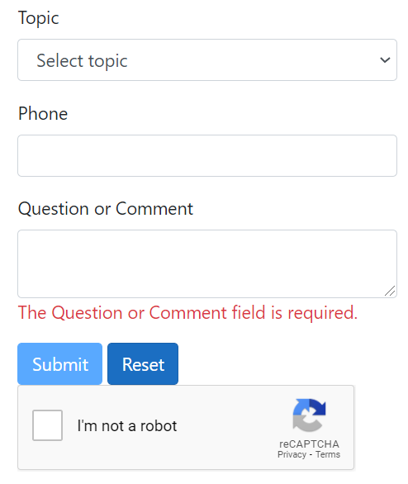

**Note:**

Submit button is disabled because reCAPTCHA did not pass yet.

**Topic Dropdown:**

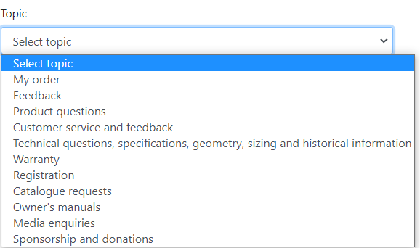

After the contact form was successfully submitted, show a Success page.

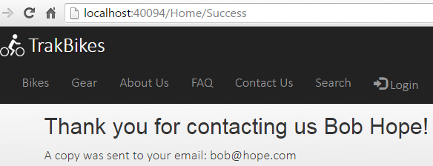

Sending an email:

* Create a dummy Gmail and password.
* Sample code SmtpClient and MailMessage object setup:

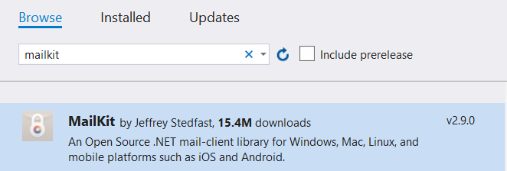



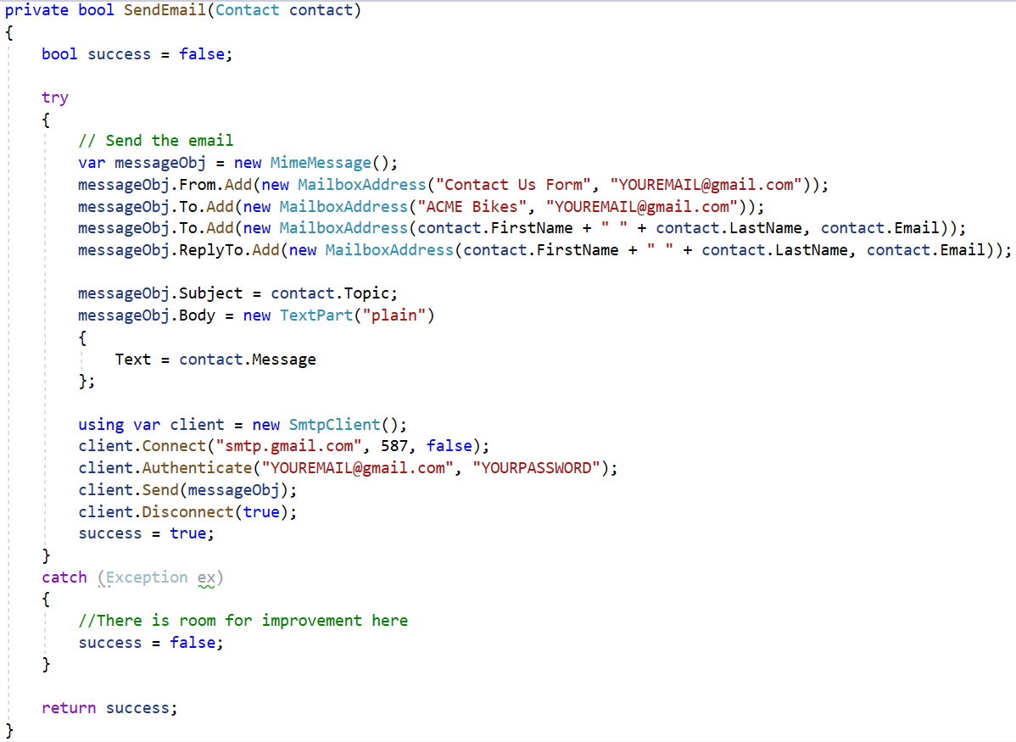

Dealing with Google’s security.

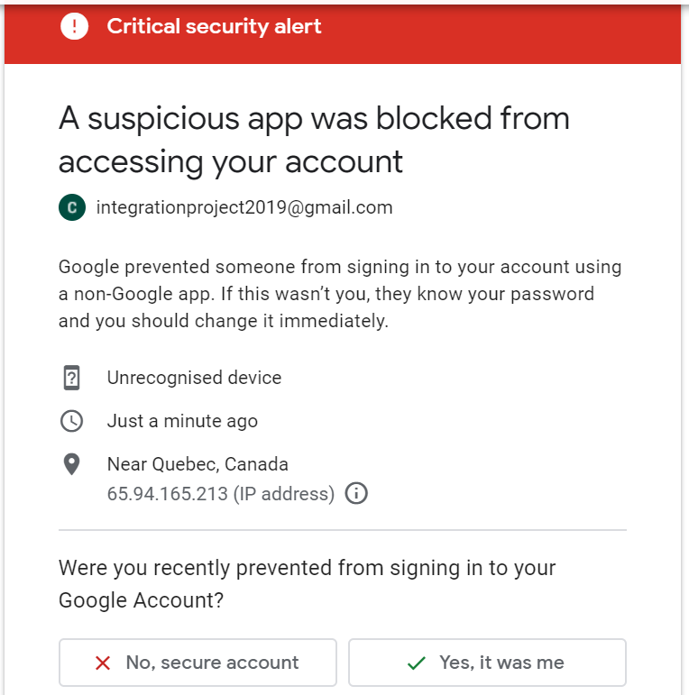

Gmail detects that the email sent isn’t from a browser and will block it by default.

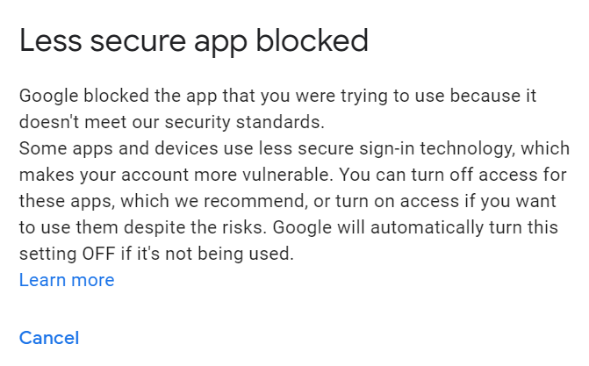

**Solution**: Turn on Less Secure App access: <https://myaccount.google.com/lesssecureapps>

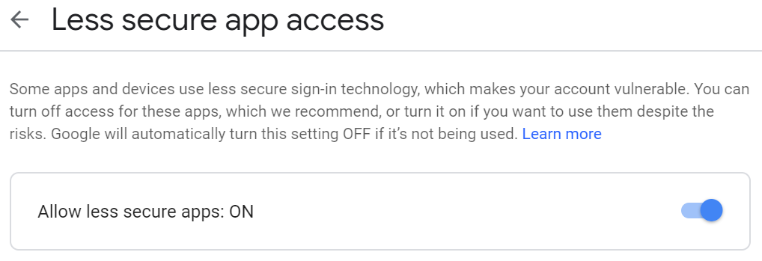

Both the company and the customer receive the same email:

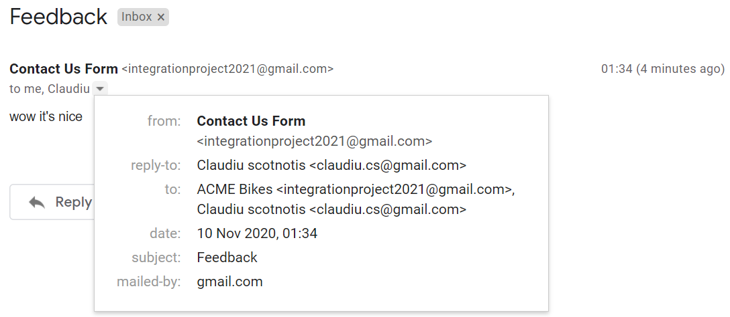

**DO NOT FORGET:** All form fields are stored in the database with the date of creation.